**Bioactive glasses with luminescent properties**

**A. Łukowiak1,*, K. Hałubek-Głuchowska1, B. Borak2, D. Szymański1, Y. Gerasymchuk1**

*1 Institute of Low Temperature and Structure Research, Polish Academy of Sciences, Wroclaw Poland*

*2 Department of Mechanics, Materials and Biomedical Engineering, Wroclaw University of Science and Technology, Wroclaw, Poland*

\**Corresponding author, e-mail: A.Lukowiak@intibs.pl*

Various types of nanomaterials play currently important roles in different fields of medicine. For example, silica–calcia system is a well-known basic composition of bioactive glasses used in regenerative medicine. Glass nanostructures might show higher activity and broader range of applications in comparison to their well-known microsized counterparts. We present studies on nanoparticles (average diameter <100 nm) of bioactive glass showing photoluminescence due to a modified composition of silica–calcia system. The sol–gel route was used to fabricate the particles. To ensure photoactivity, the composition of glass was modified by the addition of lanthanide ions or phthalocyanine complexes with metals. The optical properties (absorption and photoluminescence spectra) of the samples as well as their structural and morphological properties were examined. The results showed that glasses were active in different spectral ranges of the electromagnetic spectrum depending on the activators. Photoactivity was observed as luminescence, singlet oxygen generation or and photocatalytic dyes degradation. The bioactivity tests indicated that when particles were immersed in the simulated body fluid, ions were released into the medium, and hydroxyapatite formed on the glass surface. Described systems could be used, for example, for monitoring structural changes of the glass immersed in biological fluids, bioimaging, photodynamic therapy, or photocatalysis.

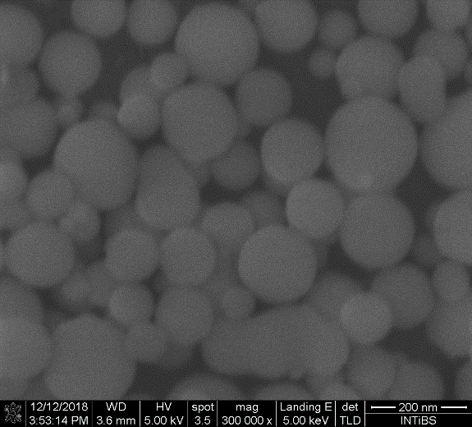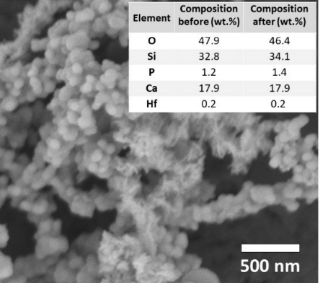

**Fig. 1**. SEM images of SiO2–CaO–P2O5 glasses activated with Eu3+ (left) or PcHfCl2 (right). Inset shows initial and final (based on EDX analysis) glass composition. Right panel from [3] (published with CC BY license).

Acknowledgment

The research was supported by the National Science Centre (Poland) grant No. 2016/22/E/ST5/00530.

**References**

1. N. A. Spaldin, R. Ramesh, Nature Mater., **18** (2019) 203.
2. S. Shevlin, Nature Mater., **18** (2019) 191.
3. Y. Gerasymchuk, A. Wedzynska, A. Lukowiak, Nanomaterials, **12** (2022) 1719, https://doi.org/10.3390/nano12101719.