Inorganic CsPbX₃ (X = Cl, Br, I) Perovskite Quantum Dots: Synthesis, Properties, and Applications

V. Klimkevičius¹, M. Steponavičiūtė¹, E. Ežerskytė¹, A. Katelnikovas^{1,*}
¹Institute of Chemistry, Vilnius University, Naugarduko 24, LT-03225 Vilnius, Lithuania
*Corresponding author, e-mail: arturas.katelnikovas@chf.vu.lt

All-inorganic perovskite quantum dots (QDs), due to their outstanding power conversion efficiency, strong absorption, and narrow and tunable emission band, have already found applications in LEDs, solar cells, photodetectors, etc. In the past decade, there have been thousands of publications dedicated to the perovskite QDs structure-property relationship and their application in various optoelectronic fields [1,2]. The first inorganic lead perovskite QDs synthesis employing the hot-injection method was reported by Kovalenko et al. in 2015 [3]. Since then, the demand for novel, easier, and faster perovskite QDs synthesis methods has gradually increased. Thus, simple, easy, and highly reproducible lead perovskite QDs synthesis routes are very desirable. This study presents a novel approach to obtain perovskite QDs. The crucial synthesis parameters, such as temperature, isolation conditions, or optical density, on the changes in optical properties were investigated in detail. The detailed verification of different parameters showed that the proposed ultrasound-induced synthesis method (see Figure 1) is superior to the conventional hot-injection method since it offers not only higher reproducibility but also a significantly shorter synthesis time, i.e., from several hours via the traditional hot-injection method to merely 20-30 minutes by our proposed method.

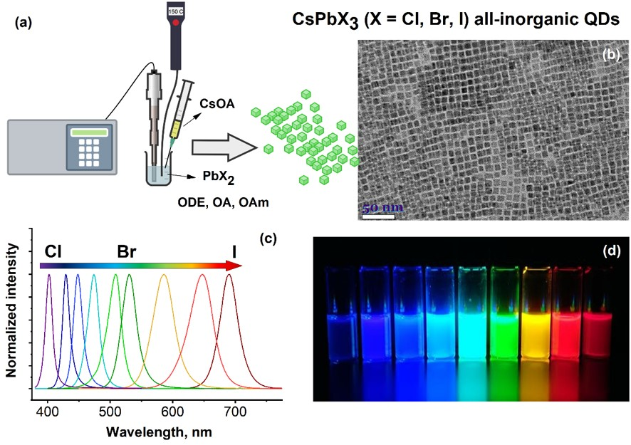
Fig. 1. Graphical illustration of the ultrasound-induced synthesis of all-inorganic lead perovskite QDs (a); TEM image of the obtained CsPbBr₃ QDs (b); PL emission spectra (c) and emission color gamut of CsPbX₃ QDs with various compositions (λ_{ex} = 365 nm) (d).

Acknowledgement. The authors acknowledge financial support from the European Regional Development Fund (project No 01.2.2-LMT-K-718-03-0048) under a grant agreement with the Research Council of Lithuania (LMTLT).

References
- M.B. Faheem, B. Khan, C. Feng, M.U. Farooq, F. Raziq, Y.Q. Xiao, Y.B. Li, ACS Energy Lett., 5 (2020) 290-320.
- W.G. Chi, S.K. Banerjee, Angew. Chem.-Int. Edit. 61 (2022) e20211241219.
- L. Protesescu, S. Yakunin, M.I. Bodnarchuk, F. Krieg, R. Caputo, C.H. Hendon, R.X. Yang, A. Walsh, M.V. Kovalenko, Nano Lett., 15 (2015) 3692-3696.

