Small Cause — Great Effect: What the 4f^{n+1}5d⁰ → 4f^{n}5d¹ configuration crossover does to the chemistry of divalent rare-earth halides and coordination compounds, and how it makes the formation of cluster complex compounds and polar intermetallics possible

Gerd H. Meyer^{1,*}
¹Department of Chemistry, University of Cologne, Greinstraße 6, D-50939 Köln, Germany

The rare-earth elements in the divalent state, i.e. with oxidation number +2, may either have the electron configuration 4f^{n+1}5d⁰ (symbolized as R²⁺) or 4f^{n}5d¹ (R³⁺e⁻). As R²⁺ (R = Eu, Yb, Sm, Tm, Dy, Nd) they can either be contained in extended solids as in the insulating diiodides RI₂, or in coordination complexes such as samarocene, Kagan’s reagent, or TmI₂(DME)₃, Fig. 1. In the case of R³⁺e⁻, the “excess” d electron can either be delocalized and cause (semi)metallic behavior in extended solids, e.g. in LaI₂, or localized with the R³⁺e⁻ = 4f^{n}5d¹ ion trapped in a coordination complex with (super)bulky ligands such as in [K(2.2.2-crypt)][LaCp”₃]. Thus, the seemingly small cause of a one-electron configuration crossover, 4f^{n+1}5d⁰ ↔ 4f^{n}5d¹ has a large effect on the chemical behavior and physical properties of the respective compounds where atomic properties and ligand effects play important roles [1].
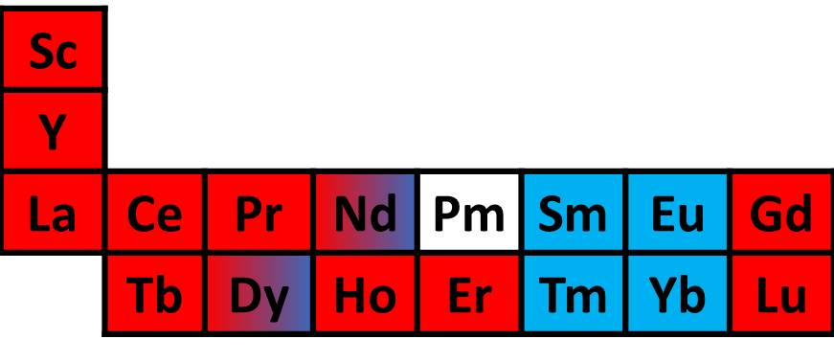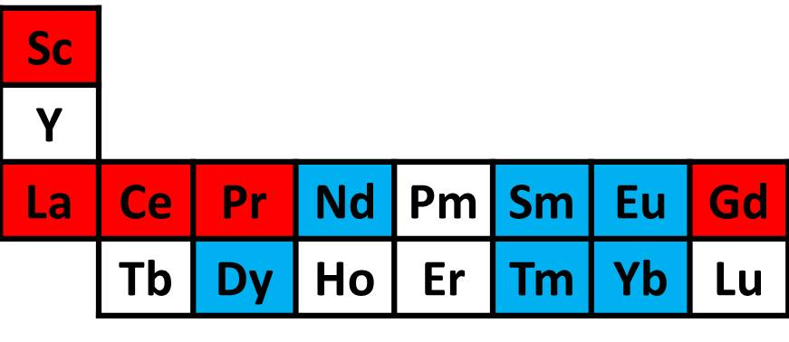

Fig. 1. Rare-earth elements R exhibiting the oxidation state +2 under ambient conditions as diiodides, RI₂, (left) and in coordination compounds (right) with their respective electron configurations: Highligthed in blue: 4f^{n+1}5d⁰, and in red: 4f^{n}5d¹.

In the solid state, dihalides with R in the 4f^{n}5d¹ configuration (including R = Y, Tb, Ho, Er, Lu) compete with cluster complex halides, {Z_{z}R_{r}}X_{x}, or polar intermetallics, {Z_{z}R_{r}}. In both cases, Z atoms center an R_{r} cluster. The endohedral atom Z, either non- or semi-metal (Z = E) or (transition) metal atom (Z = T) is mandatory for heteroatom Z−R bonding. So far, {Z_{z}R_{r}}X_{x} type compounds are known with r, i.e. the coordination number (CN) of the endohedral atom, ranging from 3 to 8. Smaller atoms like E = B, C, N, O afford smaller CN’s (3−6), while larger atoms like T = Os (and many other transition metal atoms) demand CNs of 6 to 8 [2, 3].
Bonding in these cluster complex halides {Z_{z}R_{r}}X_{x} is predominantly a symbiosis of polar, heteroatomic Z─R (intermetallic-like, multi-center covalent) and R─X (salt-like, ionic) character. Increasing cluster condensation pushes isolated clusters into oligomers, chains, double chains, then layers and, finally, three-dimensional structures. Ultimate cluster condensation, at which end all the halide ligands are eliminated, constitutes polar intermetallics.
When the electronegativity of the halide increases, there is an increasing competition of cluster complex halide versus intermetallic and salt. For example, when {PtPr₃}Cl₃ was targeted, the intermetallic {Pt₃Pr₄} as well as remaining PrCl₃ was obtained, the latter apparently working as a flux for crystal growth. Although the system Pt/Pr seems to have been investigated thoroughly, the new Pt₃Pr₄ does not exist in the phase diagram [4]. Other fluxes, such as sodium chloride instead of PrCl₃ or tin melts, resulted in the formation of what might be considered as a new modification of Pt₂Pr₃ and a number of ternary Pt/Sn/Pr intermetallics [5].

References
- G. Meyer, J. Solid State Chem. 270 (2019) 324-334.
- G. Meyer, in The rare earth elements: fundamentals and applications; Ed. D. A. Atwood, John Wiley and Sons, Inc., pp 161-173, 2012.
- G. Meyer, in Handbook on the Physics and Chemistry of Rare Earths; Ed. J.-C. Bünzli, V. K. Pecharsky, vol. 45, 111-178, Elsevier 2014.
- M. L. Rhodehouse, T. Bell, V. Smetana, A.-V. Mudring, G. H. Meyer, Inorg. Chem. 57 (2018) 9949-9961.
- M. L. Rhodehouse, V. Smetana, C. Celania, A.-V. Mudring, G. H. Meyer, Inorg. Chem. 59 (2020) 7352-7359.

