Corrosion Behaviour of Cerium Based Conversion Coatings on Zinc

A. Kirdeikienė, L. Gudavičiūtė, J. Pilipavičius, R. Juškėnas, A. Selskis, R. Ramanauskas*
Center for Physical Science and Technology, Saulėtekio al. 3, LT-10257 Vilnius, Lithuania
*Corresponding author, e-mail: rimantas.ramanauskas@ftmc.lt

Ce based coatings can be considered as environmentally friendly alternative to chromium conversion coatings to protect Zn against corrosion. These coatings can be produced by chemical treatment of metal surface in a Ce(NO₃)₃ solution and usually present a mixture of Ce (III) and Ce (IV) oxides and hydroxides. The disadvantage associated with oxide film deposition process is a crack formation through the deposited layer due to gas evolution caused by decomposition of electrolytes. Therefore, Ce based coatings did not show always a sufficient corrosion resistance. The aim of this investigation was to study the influence of the base metal Zn structural parameters on the protective and self-healing abilities of Ce based conversion coatings formed on Zn surface. Different surface analytic techniques, including SEM, XRD, XPS together with electrochemical measurements (EIS) were applied in order to obtain complementary information of this coating system.
A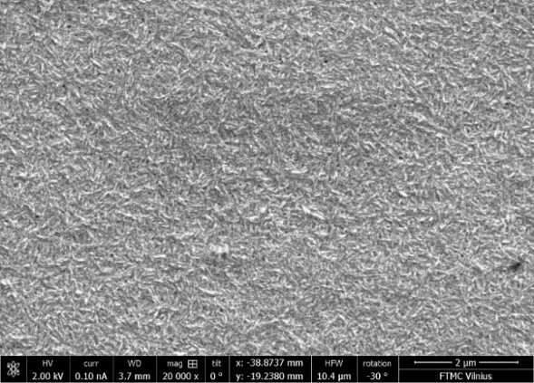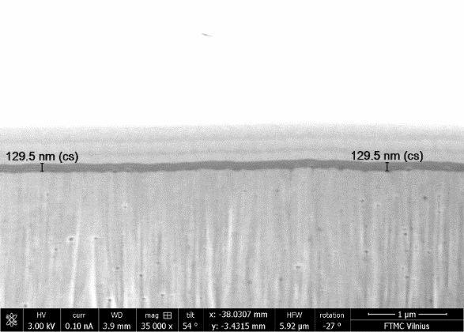 B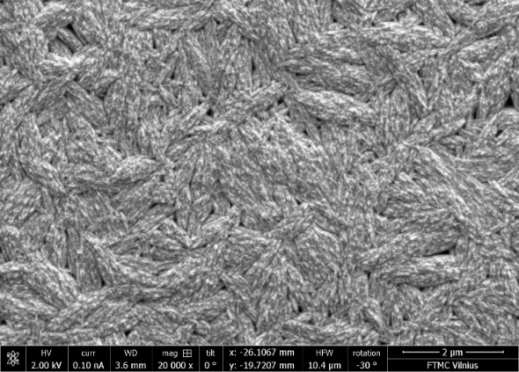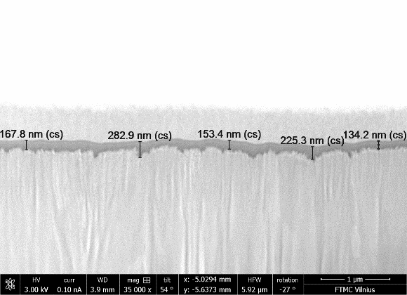

Fig. 1. SEM images of the initial Zn surface topography (left side) and cross-sections of Ce based coatings on Zn (right side), produced by direct current (A) and pulse (B) electrolysis.

Non-stationary (pulse) electrodeposition was applied for modification of Zn structural parameters, what resulted in formation of the Zn coating with the large crystallite aggregates (SEM data) and, at the same time, in two-fold reduction of the grain size and consequently increase in the number of lattice imperfection (XRD data) in comparison with a direct current (DC) plated sample. The mentioned structural differences affected significantly the process of Ce conversion film formation. It was established that Zn topography peculiarities (µm level) and the grain size (nm level) variations affect the rate of the film formation, its composition (XPS data), thickness and compactness. Ce conversion coatings deposited on the pulse plated Zn layer exhibited higher corrosion resistance (one order lower i_{corr} values) and, at the same time, higher self-healing ability in respect to DC plated sample. Lower Ce based coating porosity (higher compactness) and the higher amount of Ce (IV) oxide (XPS data) in the film, were the main reasons of the higher corrosion resistance of Ce coatings deposited on the pulse plated Zn.

