Formation and applications of nonstoichiometric titanium oxides and MXenes (Ti₃C₂T_{x}) nanostructures

S. Ramanavičius
State research institute Center for Physical Sciences and Technology, Savanorių Ave. 231, LT-02300 Vilnius, Lithuania
*Simonas Ramanavičius, simonas.ramanavicius@ftmc.lt:

In addition to stoichiometric TiO₂, recently, various nanostructured non-stoichiometric titanium oxides, which by different authors are abbreviated as TiO_{n,} or TiO_{2−x} and Magnéli phases (Ti_{n}O_{2n−1}), have received significant attention in the development of various sensors [1]. Also, recent progress in the formation of optically active titanium carbides (Ti₃C₂T_{x}) so-called MXenes encourages applications of these new 2D materials in the design of sensors, bioelectronics and some breakthrough in these areas are foreseen. The advantageous properties of MXenes are suitable for biosensing applications but are not the limitation. The other important property of MXenes is their high and near metallic conductivity altered by their surface termination groups [2], leading to a possible application as supercapacitors [3], resistive sensors [4] and other applications in electrochemistry [5], electronics [6].
This research is dedicated to investigate new ways for non-stoichiometric titanium oxides and their based nanostructures formation by wet chemical methods and searching for new applications. The main focus is on gas and biologically active molecules sensors and catalysts for hydrogen evolution reaction.
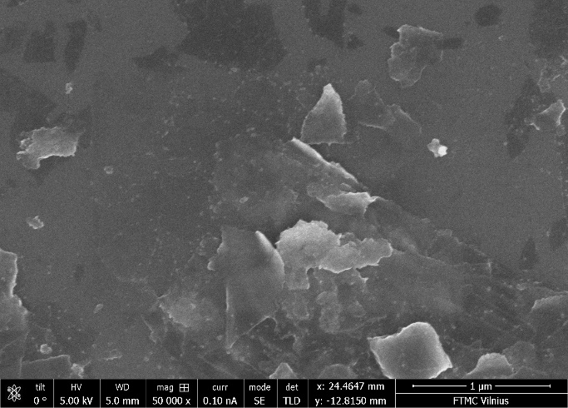
A
B
500 nm
500 nm

Fig. 1. SEM images of A – MXenes (Ti₃C₂T_{x}) sheets, B – TiO_{x} nanostructures.

References
1. Y. Wang, T. Wu, Y. Zhou, C. Meng, W. Zhu, L. Liu, TiO2-Based Nanoheterostructures for Promoting Gas Sensitivity Performance: Designs, Developments, and Prospects. Sensors., 17, (2017), 1971.
2. J.L. Hart, K. Hantanasirisakul, A.C. Lang, B. Anasori, D. Pinto, Y. Pivak, J.T., van Omme; S.J. May, Y.; Gogotsi, M.L. Taheri, Control of MXenes’ Electronic Properties through Termination and Intercalation. Nat. Commun., 10, (2019), 522.
3. S.A. Melchior, K. Raju, I.S. Ike, R.M. Erasmus, G. Kabongo, I. Sigalas, S.E. Iyuke, K.I. Ozoemena, High-Voltage Symmetric Supercapacitor Based on 2D Titanium Carbide (MXene, Ti2CTx)/Carbon Nanosphere Composites in a Neutral Aqueous Electrolyte. J. Electrochem. Soc., 165, (2018), A501–A511.
4. L. Lorencova, T. Bertok, E. Dosekova, A. Holazova, D. Paprckova, A. Vikartovska, V. Sasinkova, J. FilipP. , Kasak, M. Jerigova, Electrochemical Performance of Ti3C2Tx MXene in Aqueous Media: Towards Ultrasensitive H2O2 Sensing. Electrochim Acta, 235, (2017), 471–479.
5. D. Song, X. Jiang, Y. Li, X. Lu, S. Luan, Y. Wang, Y. Li, F. Gao, Metal−organic Frameworks-Derived MnO2/Mn3O4 Microcuboids with Hierarchically Ordered Nanosheets and Ti3C2 MXene/Au NPs Composites for Electrochemical Pesticide Detection. J. Hazard Mater. 373, (2019), 367–376.
6. H. Kim, Z. Wang, H.N. Alshareef, MXetronics: Electronic and Photonic Applications of MXenes. Nano Energy, 60, (2019), 179–197.

